//EXTERIOR - BLUE TOWN - ROSE//

Ragul and Shreesha were walking through the pluffine forest. Ragul was immersed in the surroundings. He quickly ran around screaming “Yaaaay!!”

He ran a few steps and stopped at a place. He could observe the snow slowly falling.

Ragul: (shouting, happy) Shreeshaaaaa!

Shreesha: (smiling) Sollu Ragul!

Ragul: Shreeeeeshaaaaaa!

Shreesha: (smiling) Sollu, sollu.

Ragul: (screams to the cloud in joy) SHREEEESHAAAAA!

Shreesha ran near Ragul quickly.

Shreesha: Sollu Ragul!
Ragul rolled on the snow in happiness. His hoodie carried the snow on the ground.

Shreesha: Naanum varan!

Shreesha also rolled along with Ragul in the snow.

After a few rolls, Ragul stopped and looked at Sheesha. Quickly he stood up and threw snow at her.

Shreesha quickly grabbed a pile of snow using her magic. Ragul quickly started running

Ragul: (hesitant, shouting) Aiyo, yen-kitta magic guard-lam illa.

Shreesha: Paravalaaa!

Both Ragul and Shreesha were smiling as they ran fast through the woods. Quickly the snow below him was dragged behind using telekinesis by Shreesha. He fell down and laid in tired.

Ragul was gasping, he slowly turned over and Shreesha was standing in front of him with the pile of snow.

Ragul: (hesitant) Venaaa!

The snow splashed on Ragul.

Shreesha’s joy heightened because of that.

Ragul wiped off the snow on his face. As he opened his eyes again, Shreesha was ready with another pile of snow.

Ragul: Seri podhum.

Shreesha, smiling, put the snow down.
As Ragul stood up, he noticed a beautiful winter path surrounded by trees that formed a natural arch. The scene was cool and blue, making it look magical. The ground was covered in snow, and the path led deeper into the forest. There were small round beads hanging from the branches, adding a warm glow that looked nice against the icy background.


Ragul started running inside the winter path. He was looking at those trees, touching them and feeling the chillness. He jumped to catch one of those beads, but since it was too high, he left it as it is. Shreesha also ran behind him. Becoming tired, Ragul stopped with a heavy breath, looking around, still in awe.

Ragul: (amazed) Shreesha, yenna yedam idhu?

Shreesha: Idhuvaa… idhu pluffine forest.

Ragul: (stressing) Indha yedam mattum vithyasama iruku-la... Idhu peru yenna?

Shreesha: Neraya yedam inga ipdi dhaan irukum. Yellathukum per vechey aganuma yenna?

Ragul: Rytu. Nee yerkanavey inga vandhurukiya?

Shreesha: Naan appa-kuda oru dhadava inga vandhan. Aana indha yedam konjo bore adichadhunaala, adhuku aprom varavey illa.

Ragul: (to himself) Bore-ah? Indha yedam-ah? …correct-uh dhaan. Pudhusa paakara naala yenaku pudichiruku. Aana ivunga yellam ingaye vazhravanga; bore adikka dhaan seiyum. (to Shreesha): Idhuvey unaku bore-ah! Appo yedhu unaku jolly-nu solluva?

Shreesha: Daily-um yenaku jolly maarikittey irukum. Oru naal jolly-ah irukuradhu adutha naal bore-adichidum. Daily-um naanum Aadarsh-um pudhusa pudhusa fun pannuvom. Aana Sanctuary dhaan romba jolly-ah irukum. Anga romba neram irundha dhaan bore adikum.

Ragul: Daily-um bore adikkama iruka pudhusa pudhusa explore pannitey irupeenga appo?

Shreesha: Aama! Appo-dhaana seekram God kitta poga mudiyum.

Ragul and Shreesha continued walking down the path, their footsteps soft against the snow. The glow from the hanging beads reflected off Shreesha's face, making her look even more beautiful in the soft, cool light. Ragul couldn’t help but glance at her, noticing the way her innocence shone through her every move and word.

Ragul: (thinking to himself) Dhanasree sonna madhiri… ivunga yellam romba nallavangala irukanga…

As they walked, their arms brushed lightly, sending a strange warmth through Ragul.

Ragul: (thinking to himself) Yen yenakku thappu thappu-ah yennamo thonudhu. (taking a deep breath) Shreesha, nee yepdi ivlo nallavala iruka?

Shreesha: (laughing, unaware of Ragul’s thoughts) Ipdi dhaan nan yeppomey…
Her laugh was carefree, her words light. Ragul's thoughts, however, were growing heavier, clouded by feelings he didn’t understand but couldn’t ignore.
Ragul: (moving a little closer) Shreesha, nee yeppovadhu… oru madhiri vithyasama.. Yedho nee God-oda world la irukura madhiriye oru feeling. Ne anga physical-ah illanalum, but emotional-ah feel pannirukiya?
Shreesha: God-world feel-ah… illa apdi yedhuvum na feel pannadhillaye.

Ragul smiled at Shreesha.

Ragul: (thinking to himself) Idhu thappu illa-nu dhaan nenaikuran. Aama. Indha ulagathula yedhuvumeyy thappu illa… nan yen romba yosikiren. Kandippa ipdi pannalam. Ivalum yedhum nenachuka maata.

Ragul (to Shreesha): Unakku lover yaradhu irukangala yenna?

Shreesha: ‘lover’-ah? Apdina?

Ragul: (thinking) love kooda illaya inga? Illa… vera peru irukumo? (to Shreesha) Yepdi… kolandha yellam… inga porakum?

Shreesha: Adhuva… Sanctuary-la Tharah tree irukum. Anga appa-vum amma-vum kai vechaa, andha maram kolandha kudukum; adhula irundhu dhaan kolandha yellam porakum. Nanum anga irundhu dhaan vandhan.

Ragul: Apoo… (hesitating) sex yellam illaya inga?

Shreesha: (smiling) sex-ah? Apdina?

Ragul's heart raced, torn between the purity of the moment and the growing desire inside him. He knew Shreesha didn’t understand the weight of his words.

Ragul: Innaiku nee kaalaila kudutha pazham taste-ah irundhuchu.

Shreesha: (warm) Thank you.

Ragul’s mind spun as they continued down the path. Shreesha's innocence only made the pull he felt stronger, more overwhelming. He looked at her, the light snow clinging to her hair, the soft glow from the beads reflecting in her eyes.

They stopped for a moment under the arch of trees. The forest was quiet, and Ragul’s heart started beating faster. He reached out, touching her arm gently.
Ragul: (thinking) Saavaraku munnadi ipdi oru experience panradhu thapilla (softly, to Shreesha) Shreesha...
She turned to him, her eyes wide with curiosity. Ragul stepped closer, his breath shaky.
Ragul: (whispering) Yenna namburala?
Shreesha: (nodding) Kandippa, Ragul.
Her words sent a rush through him and his hands were trembling a little as he held her chudi.
Shreesha: (excited) Ragul... idhu yenna game?
Ragul: (barely able to speak) Yenna namburala…
Shreesha responded with a big smile.
Ragul carefully began to pull the chudi over her head. The fabric slid away, revealing her skin beneath, illuminated by the soft glow of the lights. Ragul’s fingers trembled, both from desire and the weight of the moment. He took his time, savoring the sight of her as she stood there, vulnerable yet beautiful.
As he moved to her pants, he felt the rush of emotions—nervousness mixed with an undeniable yearning. The sound of the birds and the wind outside them faded into the background, and it felt as if they were the only two people in the world.
Just as he gently peeled away her pants, Ragul took his hands closer to touch her skin. But a sudden noise shattered the moment. The rustle of footsteps echoed from further inside the other end of the pathway, pulling Ragul out of the half-conscious state. He froze, heart pounding, as he turned to see who had interrupted them.
It was a young girl with white skin and dark black hair, wearing a ponytail, with a normal white dress. She also had a pink flower in her head. Nestled behind her right ear, a small thing shimmered like violet glass, catching the light with every tilt of her head with star-shaped dangling ornament. Her body looked injured as she had big scars in her leg and her left arm was covered in pluffine wool like protection.

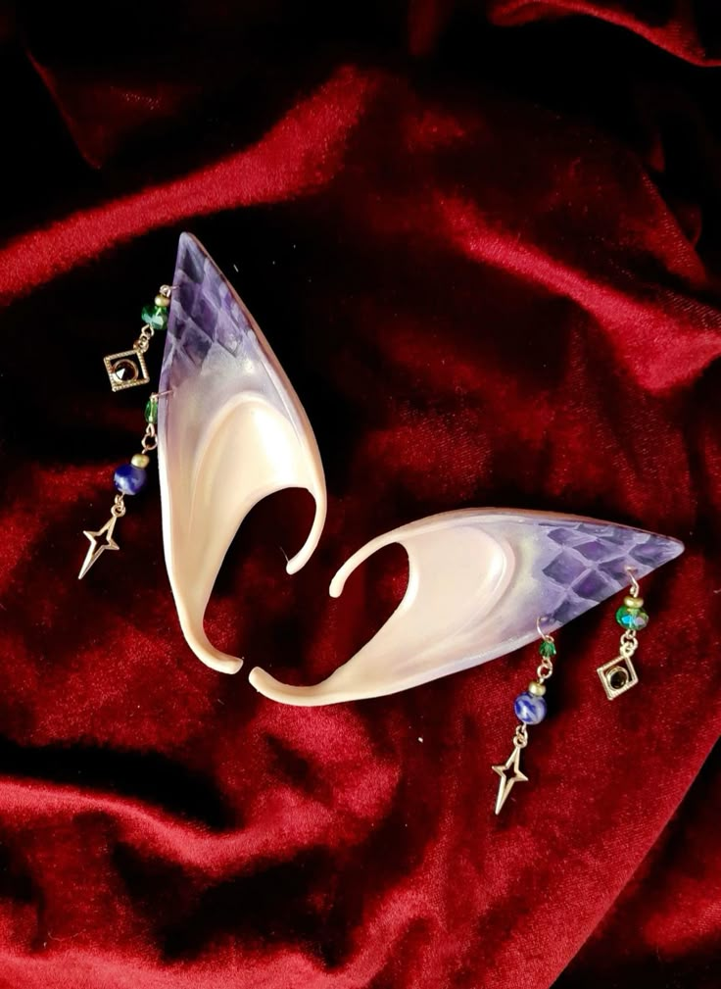

Pink-flowered girl: (confused) Yenna nadakudhu inga?

Ragul: (nervous) Illa.. theriyama panniten- (thinking to himself) Ivungaluku dhaan onnum theriyadhula… (to the ‘pink-flowered girl’, smiling) Chumma game.

The ‘pink-flowered girl’ looked at Shreesha standing naked and Ragul in full clothes.

Pink-flowered girl: (to himself, raged) Tch! Kolveri pudicha miruganga… (to Shreesha) Avanoda idupula speed ah pani ah thooki podu, na unaku oru magic kaaturan.

Ragul (to Shreesha, frightened): Illa vena!

Shreesha: (smiling as she made a large snowball) Indhaaa!

Shreesha quickly splashed Ragul and fell with a pile of snow above. He couldn’t get up.

Shreesha jumped in happiness as she saw him fell. He coughed snow as he breathed heavy

Ragul: (panicking, to shreesha) Yenna vidu… (cough) idha yedu yen mela irundhu.

Shreesha (turning to the pink-flowered girl with the smile unfaded): Magic kaatunga.

Pink-flowered girl: Oru nimisham iru.

The pink-flowered walked weakly and stood close to Ragul.

pink-flowered girl: (trying to catch his neck) Ipdi panradhuku unaku vekkama illa?

She tried to grab Ragul’s hand, but due to the snow that covered Ragul’s arm, he was able to slip away. The pink-flowered girl chased him. Shreesha was confused.

Ragul was running fast without turning back, the beads reflection seen in his sweat.

Ragul: (nervous) Idhu yaara irukum?! Ivungaluku sex-yellam theriyuma yenna?

He then exited the pathway as he ran away from her. His breath gasping “Inga irukavanga yellarum nallavanganu dhaana sonna Dhanasree…! Aprom yepdi iva sanda yellam podura?”

[Dhanasree: Oruthana thavara]

Ragul (thinking as he ran tense): Idhu dhaan andha oruthano… Illa, indha ponnu vera yaro…. Oruvela andha oruthan, ‘oruthi’ ah vesham potutano… yenna nadakudhuney purila!

Shreesha still stood there with a puzzled look, watching as Ragul ran, her eyes wide with surprise.

Ragul was sweating even in the chill weather. He ran fast even though the snow was heavy on the ground

Pink-flowered girl: (chasing) Dei bayandhangoli, nillu da!

Ragul didn’t care about her words and ran as fast as he could while the pink-flowered girl chased him as she stumbled while running.

Shreesha, still unaware, wore her clothes and followed behind slowly, her soft laugh echoing through the snowy path.

Shreesha: (in awe) Ragul romba speed-ah poran! Nan seekram poi avana mundhanum!

The distance between the pink-flowered girl and Ragul increased and Ragul, trembling and stumbling, finally managed to get away, disappearing into the snowy woods.

Pink-flowered girl: (muttering) Avan aalum moonjiyum. Erichal-ah varudhu ipdi irukavangala paathaley…

She stood still thinking deep.

//Intercut//

Ragul running finally stopped, ensuring he escaped from them. He was taking breaths, his breath slowened gradually.

Ragul: (muttering) Thank you, ponnu.

//Cut to//

//EXTERIOR - LAVENDER FOREST//

The White dressed girl parked the wolf near a tree. Nithish was still bleeding, surrounding him everywhere was those purple beaded trees. He grabbed a tree nearby for balance, each tiny movement making the pain worse.

“Ah” he groaned, shutting his eyes as he tried to take shallow breaths, each breath making the wound on his back sting even more.

The White dressed girl quickly tucked out the chudi (top). And tear a portion of it with her sword.

Nithish was struggling in pain, as he tried to scratch near the wound for relief, and the blood drops fell on the broken cuff tied to his hand. The wolf was wandering around playing in the snow.

White dressed girl: Unnoda sattaiya kalatu.

Nithish looked at the girl with half attention, and also looked at the piece of cloth. His eyes were wet, a tear from his eye washed the blood on the cuff.

As he slowly tried to remove his shirt, “Ah!!” he husked in pain. He couldn’t remove it.

The White dressed girl moved forward, placing the cloth torn from her chudi in her belt, slowly removing Nithish’s shirt and tied his back with the torn cloth.

White dressed girl: Yaaru avan, yedhuku unna kolla paakuran?

Nithish let out a slight scream “Hsss!” in pain.

Nithish: Yenakum therila. Naaney ippo dhan indha yedathuku vandhurukan. Avan yenna mairuku yenna kolla varan?!

White-dressed girl: (confused) Mayira?

Nithish looked at her in stress and just ignored.

White-dressed girl: Sollu apdi-na yenna?

Nithish: Adhu tension la soldradhu.

White dressed girl: Sari. (tucking her chudi back in) Vettu-kaayam dhan, vera yedhuvum illa. Ratham varadhu, seekram ninnudum. ‘Puina’ poo-oda saaru-ah pulinju vitta, un kaayam konjo seekram aaridum.

Nithish looked at her confused.

White dressed girl: Neva-la iruku andha chedi. Oru-manneram avadhu aagum. Yendhiri polam. Namma inga iruka iruka, unaku dhaan prechana. Avan yeppa venalum inga varalam.

Nithish: Modhala… yedhuku yenna kaapathuneenga? Na ungakitta sanda yellam potum… Anga irundhavanga yellam… oruthar kooda varadhapo… neenga mattum yen?

White dressed girl stared at him, and observed his facial expressions due to his pain. A memory incurred to her.

[ Nithish shouted desperately “Yaaravadhu udhavungalen!!!” ]

Then she quickly ignored him and went to tighten the cart’s knots.

Nithish: (eyes narrowing) Illa modhala, Idhu yenna yedam-nu sollunga?!

White dressed girl: Lavender Forest.

Nithish clenched his fists.

Nithish: (to himself) Idhu oru nejamana yedam na, modhala na yepdi inga vahdhan? Yosi Nithish… na kadasiya Boomi-la sodakku potan. Aprom yellamey yenaku oru madhiri iruta maariduchu. Yendhirchu paatha indha yedathula irukan. Yepdi-nu therila. Idhuku munnadi yellam na veetla neraya sodakku potrukan. Appo yen yedhuvum nadakala?! Aana oru, rendu-moonu naal-ah ah dhan yen kaiya kitta konduponaley yedho feel aagudhu. Nanum perusa kandukala indha saavu nadandha tension-la. Aana…Dhanasree, Dhanasree-ku yennamo therinjuruku yenna pathi. Adhanala dhaan ava yen kooda close-ah palagiruka. Oru-vela Ragul-kum idha pathi theriyumo? Avana…! Innum avan yen yenna maati vittan-nu yenaku therila. Aana ippo na modhala Boomi-ku poganum. (taking a deep breath) Na sodakku potu dhaana inga vandhan. Appo innoru sodaku pota na thirumba polam dhaana…

White dressed girl: Ingaye irundhana kulurlaye sethuruva. Vandhu cart-la yeru.

Nithish: Indha yendathula, sodakku pota vera yedathuku poga mudiyuma?

White-dressed girl (glaring): Illa. Yen?

Nithish (frightened): Na… na apdi dhan yen yedathula irundhu indha yedathuku vandhan.

White-dressed girl: Sodakku pota…?

Nithish: Aama… Naan, yen-kooda oru moonu per. Avunga yellarum yenna pudichikitanga. Orey sodakku dhan potan. Paatha indha yedathuku vandhutan.

White-dressed girl (engaged): Appo unnala sodakku pota oru yedathula irundhu innoru yedathuku poga mudiyuma?!

Nithish closed his fingers as he observed his nerves shimmering for a brief moment in red.

Nithish: (to himself) Adhey feeling (to White-dressed girl): Aama… aana yepdi nu therila. Yendha yedathuku naama povom-nu yenaku theriyadhu.

The white-dressed girl stood silent as she thought for a moment.

White-dressed girl: Paravala. Yenna venalum pandren-nu sonnala… yenaku oru udhavi pannanum nee.

Nithish looked confused.

//Screen fades//

